Manuscript Type (Write a type of your manuscript; Research Paper, Research Overview, Study ofMaterial, or Short Note)
Thesis Title:
Subtitle (if any)
Name (Affiliation) *Maintain anonymity for submission and during peer review
*Instruction: This template contains modified styles for submissions to The Japanese Journal of Language in Society. Find and apply appropriate styles for each text. This instruction is applied ‘abstract_English’ style as an example.
Keywords: keyword1, keyword2, keyword3, keyword4, keyword5
Thesis Title in Japanese
Subtitle in Japanese (if any)
Name in Japanese（Affiliation in Japanese） ※Maintain anonymity for submission and during peer review
Abstract in Japanese
キーワード（Keywords in Japanese）：keyword1，keyword2，keyword3，keyword4，keyword5

- Chapter Title
Use ‘headline 1’ for chapter titles. This style defines the first heading level.
Xxxxxx xxxxxx xxxxxx xxxxxx xxxxxx xxxxxx xxxxxx xxxxxx xxxxxx xxxxxx xxxxxx xxxxxx xxxxxx xxxxxx xxxxxx xxxxxx xxxxxx xxxxxx xxxxxx xxxxxx xxxxxx xxxxxx xxxxxx xxxxxx xxxxxx xxxxxx xxxxxx xxxxxx xxxxxx xxxxxx xxxxxx xxxxxx xxxxxx xxxxxx xxxxxx xxxxxx xxxxxx xxxxxx xxxxxx xxxxxx xxxxxx xxxxxx xxxxxx xxxxxx xxxxxx xxxxxx xxxxxx xxxxxx xxxxxx xxxxxx xxxxxx xxxxxx xxxxxx xxxxxx xxxxxx xxxxxx xxxxxx xxxxxx xxxxxx xxxxxx xxxxxx xxxxxx xxxxxx xxxxxx xxxxxx
For body of text, select ‘paragraph 2-0’. The first line will be indented automatically in each paragraph. If you select ‘paragraph 0-0’, the text will begin without indentation.
Xxxxxx xxxxxx xxxxxx xxxxxx xxxxxx xxxxxx xxxxxx xxxxxx xxxxxx xxxxxx xxxxxx xxxxxx xxxxxx xxxxxx xxxxxx xxxxxx xxxxxx xxxxxx xxxxxx xxxxxx xxxxxx xxxxxx xxxxxx xxxxxx xxxxxx xxxxxx xxxxxx xxxxxx xxxxxx xxxxxx xxxxxx xxxxxx xxxxxx xxxxxx xxxxxx xxxxxx xxxxxx xxxxxx xxxxxx xxxxxx xxxxxx xxxxxx xxxxxx xxxxxx xxxxxx xxxxxx xxxxxx xxxxxx xxxxxx xxxxxx xxxxxx xxxxxx xxxxxx xxxxxx xxxxxx xxxxxx xxxxxx xxxxxx xxxxxx xxxxxx
(1) If you select ‘paragraph 0-2’, the first line will begin without indentation. Two-space indentation will appear from the second line. This style will be useful when you list items. xxxxxx xxxxxx xxxxxx xxxxxx xxxxxx xxxxxx xxxxxx xxxxxx xxxxxx xxxxxx xxxxxx xxxxxx xxxxxx xxxxxx xxxxxx xxxxxx xxxxxx xxxxxx xxxxxx xxxxxx xxxxxx xxxxxx xxxxxx xxxxxx xxxxxx xxxxxx xxxxxx xxxxxx xxxxxx xxxxxx xxxxxx xxxxxx xxxxxx xxxxxx xxxxxx xxxxxx xxxxxx xxxxxx xxxxxx xxxxxx xxxxxx xxxxxx xxxxxx xxxxxx
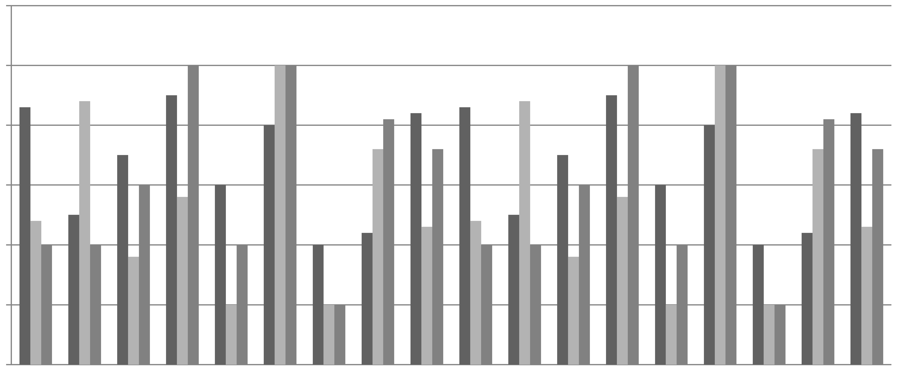
Figure 1 Figure Title 2s xxxxxxxxxx xxxxxxxxxx xxxxxxxxxx xxxxxxxxxx xxxxxxxxxx xxxxxxxxxx xxxxxxxxxx xxxxxxxxxx xxxxxxxxxx xxxxxxxxxx xxxxxxxxxx xxxxxxxxxx
For figure legend, select ‘figure caption 1s’ for one line title, or chose ‘figure caption 2s’ for a title with two or more line. If you describe the figure, apply ‘figure note’ style to the caption.
  - Section Title
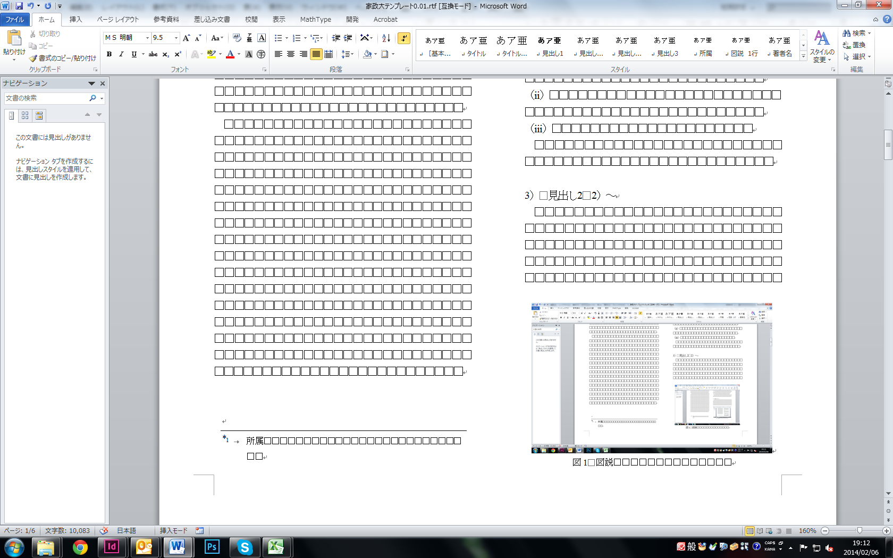
Figure 2 Figure Title 1s xxxx xxxx xxxx
Use ‘headline 2’ style for section title. This style defines the second heading level. xxxxxx xxxxxx xxxxxx xxxxxx xxxxxx xxxxxx xxxxxx xxxxxx xxxxxx xxxxxx xxxxxx xxxxxx xxxxxx xxxxxx xxxxxx xxxxxx xxxxxx xxxxxx xxxxxx xxxxxx xxxxxx xxxxxx xxxxxx xxxxxx xxxxxx xxxxxx xxxxxx xxxxxx xxxxxx xxxxxx xxxxxx xxxxxx xxxxxx xxxxxx xxxxxx xxxxxx xxxxxx xxxxxx xxxxxx xxxxxx xxxxxx xxxxxx xxxxxx xxxxxx xxxxxx xxxxxx xxxxxx xxxxxx xxxxxx xxxxxx xxxxxx xxxxxx xxxxxx xxxxxx xxxxxx xxxxxx xxxxxx xxxxxx xxxxxx xxxxxx xxxxxx xxxxxx xxxxxx xxxxxx xxxxxx xxxxxx xxxxxx xxxxxx xxxxxx xxxxxx xxxxxx xxxxxx xxxxxx xxxxxx xxxxxx xxxxxx xxxxxx xxxxxx xxxxxx xxxxxx xxxxxx xxxxxx xxxxxx xxxxxx xxxxxx xxxxxx xxxxxx xxxxxx xxxxxx xxxxxx xxxxxx xxxxxx xxxxxx xxxxxx xxxxxx xxxxxx xxxxxx xxxxxx xxxxxx xxxxxx xxxxxx xxxxxx xxxxxx xxxxxx xxxxxx xxxxxx xxxxxx xxxxxx xxxxxx xxxxxx xxxxxx xxxxxx xxxxxx xxxxxx xxxxxx xxxxxx xxxxxx xxxxxx xxxxxx xxxxxx xxxxxx xxxxxx xxxxxx xxxxxx xxxxxx xxxxxx xxxxxx xxxxxx xxxxxx xxxxxx xxxxxx xxxxxx xxxxxx xxxxxx xxxxxx xxxxxx xxxxxx xxxxxx xxxxxx xxxxxx xxxxxx xxxxxx xxxxxx xxxxxx xxxxxx xxxxxx xxxxxx xxxxxx xxxxxx xxxxxx xxxxxx xxxxxx xxxxxx xxxxxx xxxxxx xxxxxx xxxxxx xxxxxx xxxxxx xxxxxx xxxxxx xxxxxx xxxxxx xxxxxx
    - Subsection Title
If you create further divisions in your chapter, use ‘headline 3’ style. xxxxxx xxxxxx xxxxxx xxxxxx xxxxxx xxxxxx xxxxxx xxxxxx xxxxxx xxxxxx xxxxxx xxxxxx xxxxxx xxxxxx xxxxxx xxxxxx xxxxxx xxxxxx xxxxxx xxxxxx xxxxxx xxxxxx xxxxxx xxxxxx xxxxxx xxxxxx xxxxxx xxxxxx xxxxxx xxxxxx xxxxxx xxxxxx xxxxxx xxxxxx xxxxxx xxxxxx xxxxxx xxxxxx xxxxxx xxxxxx xxxxxx xxxxxx xxxxxx xxxxxx xxxxxx xxxxxx xxxxxx xxxxxx xxxxxx xxxxxx xxxxxx xxxxxx xxxxxx xxxxxx
If you insert quotations more than two lines, apply ‘blockquote’ style. The segment will be separate from your body of text as the following shows.
Manuscripts may be submitted in either Japanese or English. The title, the abstract and the keywords must be written in both English and Japanese. (The Japanese Association of Sociolinguistic Sciences, 2015). xxxxxx xxxxxx xxxxxx xxxxxx xxxxxx xxxxxx xxxxxx xxxxxx xxxxxx xxxxxx xxxxxx xxxxxx xxxxxx xxxxxx xxxxxx xxxxxx xxxxxx xxxxxx xxxxxx xxxxxx xxxxxx xxxxxx xxxxxx xxxxxx xxxxxx xxxxxx
If you insert formulas, you can use ‘equation’ style¹⁾. The text will be spaced and indented as the below shows.
Table2 Table Title 2s xxxxx xxxxx xxxxx xxxxx xxxxx xxxxx xxxxx xxxxx xxxxx xxxxx
text

Table 1 Table Title 1s
*When a table title is within one line, apply ‘table caption 1s’. If you write a title with two lines or more, chose ‘table caption2s’.
*In tables, select ‘table body’ style. The font size will be 8 point.
If definitions or explanations are written immediately below the table, the sentences can be set up with ‘table note’ style.
X+Y=Z
Additional Remarks (Optional)
Xxxxxxxx xxxxxxxxx xxxxxxxxx xxxxxxxxx xxxxxxxxx xxxxxxxxx xxxxxxxxx xxxxxxxxx xxxxxxxxx xxxxxxxxx xxxxxxxxx xxxxxxxxx xxxxxxxxx xxxxxxxxx xxxxxxxxx xxxxxxxxx xxxxxxxxx xxxxxxxxx xxxxxxxxx xxxxxxxxx xxxxxxxxx xxxxxxxxx xxxxxxxxx xxxxxxxxx xxxxxxxxx xxxxxx xxxxxx xxxxxx xxxxxx xxxxxx xxxxxx
Acknowledgements (Optional)
Xxxxxx xxxxxx xxxxxx xxxxxx xxxxxx xxxxxx xxxxxx xxxxxx xxxxxx xxxxxx xxxxxx xxxxxx xxxxxx xxxxxx xxxxxx xxxxxx xxxxxx xxxxxx xxxxxx xxxxxx xxxxxx xxxxxx xxxxxx xxxxxx xxxxxx xxxxxx xxxxxx
Endnotes (Optional)
1) Apply ‘note’ style for endnotes. In your body text, the number must be superscript with a right-half parenthesis. The example is shown on the first sentences in this page.
References
Apply ‘reference’ style for the list of references．
Atlas, Jay D. (2004). Presupposition. In Horn Laurence R., & Ward, Gregory (Eds.), The handbook of pragmatics, pp.29-52. Malden, MA: Blackwell.
Dorian, Nancy C. (Ed.) (1989). Investigating obsolescence. Cambridge: Cambridge University Press.
Hashimoto, Yoshiaki (Ed.) (2005). Kōza Shakai Gengo Kagaku 2 Media (英訳を付す). Tokyo: Hituzi Syobo.
Haga, Jun (1963). Nihonjin Gakusei no Gakushūshita Eigo Meishi no Imi Kozō no Hikaku Kenkyū. Kyōiku Shinrigaku Kenkyū (英訳を付す), 11, 33-42.
Hymes, Dell (1972). Models of the interaction of language and social life. In Gumperz, John, & Hymes, Dell (Eds.), Directions in sociolinguistics, pp.35-71. New York: Holt, Rinehart & Winston.
Kita, Sotaro (1993). Language and thought interface: A study of spontaneous gestures and Japanese mimetics. Doctoral Dissertation, Department of Psychology and Department of Linguistics, University of Chicago, Chicago, Illinois.
Lave, Jean, & Wenger, Etienne (1991). Situated learning: Legitimate peripheral participation. Cambridge: Cambridge University Press. (trans, Saeki, Yutaka (1993). Jokyo ni Umekomareta Gakushu. Tokyo: Sangyotosho)
Norrick, Neal R. (2000). Conversational narrative: Storytelling in everyday talk. Amsterdam: John Benjamins Publishing Company.
Sacks, Harvey, Schegloff, Emanuel, & Jefferson, Gail (1974). A simplest systematic for the organization of turn-taking for conversation. Language, 50 (4), 696-735.
Shakai Gengo Kagakukai (2004). Genkoboshu no oshirase. Shakai Gengo Kagakukai 2004nen 11-gatsu 8-nichi (英訳を付す).
<http://www.jass.ne.jp/ed/gakkaisi.html> (June 20, 2007)
Shibuya, Katsumi (2000). Tokugawagaku no Nagare－Hōgengaku kara Shakai Gengogaku e－Shakai Gengo Kagaku (英訳を付す), 2 (2), 2-10.
Sibata, Takesi (1978). Shakai Gengogaku no Kadai. Tokyo: Sanseido.
Spitzberg, Brian H., & Cupach, William R. (1984). Interpersonal communication competence. Beverly Hills, CA: Sage.

Takeuchi, Ikuko (1982). Juyō Katei no Kenkyū (英訳を付す). In Takeuchi, Ikuo, & Kojima, Kazuto (Eds.) Gendai Masukomyunikēshonron, pp.44-79. Tokyo: Yuhikaku.
Yamada, Hiroshi (2007). Gammen Hyōjō Ninshiki ni Okeru Jōhōshori Katei (英訳を付す). Shakai Gengo Kagakukai 19 Kai Taikai Happyō Ronbunshū, pp. 346-349.
Yasuda, Saburo, & Umino, Michio (1977). Shakai Tōkeigaku (英訳を付す), 2nd edition. Tokyo: Maruzen.
Zajonc, Robert B. (1980). Feeling and thinking: Preferences need no inferences. American Psychologist, 35, 151-175.

Adaption data information
（20XX年X月X日受付）
（20XX年X月X日修正版受付）
（20XX年X月X日掲載決定）
*You do not need to edit this section

